Year 4 Interactive Media Development Assignment 1

Gavin Hickey | X00109563

Solo Project

## Game Choice

For my project, I have chosen to choose the classic 8-bit game title, Space Invaders.

This game can be seen in the mentioned list of games that is recommended for this project,

see link - <http://www.8bit.com/>

## What is Space Invaders?

Space Invaders is an old 8-bit video game in which the player must control a pixelated tank to help destroy an oncoming wave of aliens while dodging enemy lasers and using the provided shield as cover.

First released in 1978 by Taito, it was developed by Tomohiro Nishikado who was inspired by many sci fi films. The creation of this game helped pave the way for future video game helping the video game industry go from a novelty to a global industry.

The game grew in popularity and was eventually licensed for use in the United States within coin-operated arcades, the Atari 2600 and the Nintendo Entertainment system. Throughout its lifetime, the game has generated more than 500 million dollars in revenue.

## Why choose Space Invaders?

Besides the game being within the list of old titles recommended for this project =, I have chosen this title due to its notoriety. When I think about the retro 8-bit games during the arcade era where anyone that wanted to play a video game had to go down to their local arcade with a fist full of coins to play rather that todays world where you can play games from home systems to you own phone I always go to the classics, Donkey Kong, Super Mario, Galaga and of course… Space Invaders.

Space Invaders is always seen or mentioned when looking through old retro titles online. You don’t need to go far in order to see this classic retro title. So it was a no brainer when choosing this as my focus for a classic 8-bit video game.

## My Approach

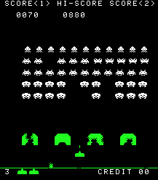When starting the development of this video games I look to the references online. Considering the how famous Space Invader it wasn’t hard to find a reference to the old-school Space Invaders to begin.

Here we see the old-style Space Invaders which we will be relocating. This is the reference I used to create a list of what was needed so we could begin.

* The Player

First off we see the player in the form of the tank battling the aliens. This player would be moving along the x axis only, moving left and right.

The player would be able to fire lasers in order to destroy the aliens

* The Aliens

The aliens will be moving left and right moving downwards slowly increasing their speed as they go, while randomly firing at the player.

* Shields

The shield would be an object used by the player to help protect them from incoming enemy lasers. This object in unique in the fact that the player would be able to fire through it. Each time it hit by either the player of the aliens it will chip away its protection.

* A score

The game features a scoring system that awards the player points for each alien they destroy that will add up on the screen. This score can also contribute to a hi score that other players can compete to top.

* Lives

The game has a lives system implemented so that the player has more chances to win instead of only having one making the game too difficult.

* Ufo

A random Ufo is also within the game which will appear at some point within the game for a short period. If the player manages to destroy this saucer, then they will be grant bonus point to help them achieve a higher score. This is not seen within the screen shot but is within the game.

With this list of object within the game I began my development process.

#### The Player

The first task was the creation of the player object. Because without a player object how was the player able to play the game. I began this by selecting my sprite sheet and selecting the tank sprite as well as the many other sprites from which I would be using at later points of the projects 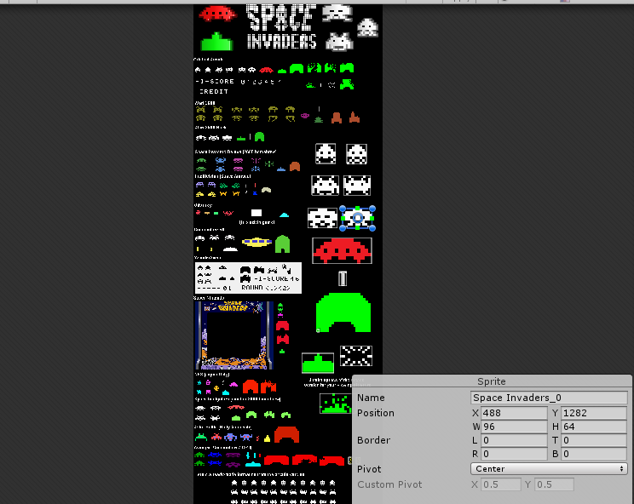development.

This sprite is then used with the creation of a game object that will have a rigid body 2d and a box collider that will be used with various script to enable different actions within the game.

Then I created my script to move the player. This script takes the input from the keyboard and moves when certain keys are pressed.

The next action implement was creating a way to shoot as the player. We created a prefab object to be instantiated when the user press a button this object have a rigidbody2d, a box collider and a sprite for visualisation. This object has also been c=given scripts so it can interact with other object such as the aliens. The object spawns at a position infront of the player and then moves upwards until it the boundary box collider of the level.

**NOTE:** Setting a boundary it very important due to the fact that even though the object might continue past the point of view within the game it is still within the game and therefore will be continually track, if more and more object is created then the game will become slower and slower due to the fact that it will be tracking all of these objects.

The player is also given other attributes for the other parts of the game such aas a count for the lives it has to work with the lives manager script.

#### The Aliens

The aliens are another part of the game of big importance.

Creation of these goes along the same process as the creation of the player but with some differences.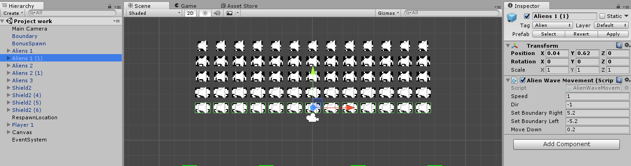

The sprites are changed and each line of aliens is assigned to its own container. Multiple sprites are used and animation of the alien objects is created. The lasers fire with a similar process except the speed of the enemy laser object is reversed so it is fire downward since the laser will be going along the *negative* of the y axis. Each alien is given a set of attributes through their varying scripts.

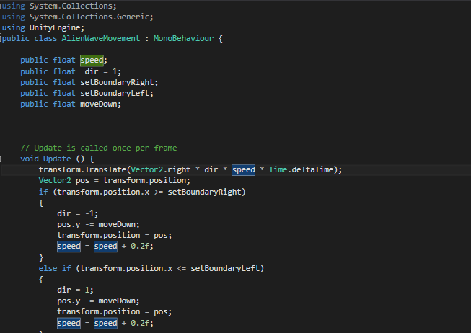

It is given a score set within the inspector of unity to go to the score manager that will add to the score each time they are destroyed, a count that will be used to help determine the end of the game where all 65 aliens, a shoot time and random counter used to help randomise the rate of fire of the aliens so that is not predictable and a moving script to make the waves of aliens move in unison formation that goes left and right while increasing slightly in speed.

The aliens object are set to use the various tags by other game objects to help control the various outcomes of their scripts for example. The alien can be destroyed by the players lasers that are tagged “Lazer” but will not be destroyed by their own lasers because they are tagged as “enemyLazer”.

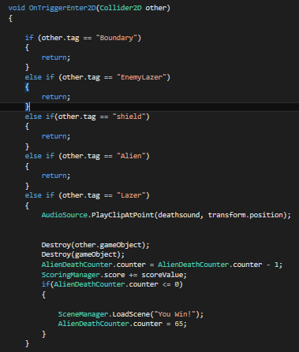

The aliens are also attached with an audio clip that will play when they are destroyed.

#### Shields

The shields are an interesting part of the Space invaders game due to the way they interact within the game. A can damage the shield but so can the player, using this as a classic advantage to shoot up through the shield. This is done by creating the shield through individual game object that are set to be destroyed upon contact with these lasers, creating it like a brick wall that can destroyed but only brick by brick, allowing the player to shoot through it after creating a path through these bricks.

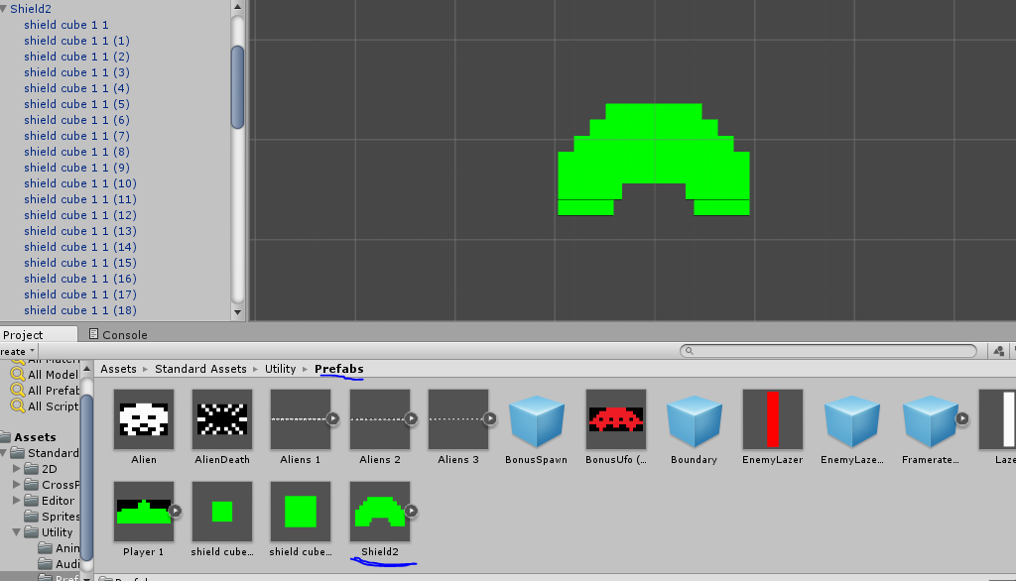

The shield can also be eroded away if it meets the aliens themselves if they get close enough. All of this is done again with the use of the tags of each object.

#### Score

The score within the game is created using the UI feature within Unity. With the creation of a Ui sits on top of the game view the score is set to the corner of the canvas as a text view to be modified with an alien is destroyed and initialises the script to add the points to the text within the UI.

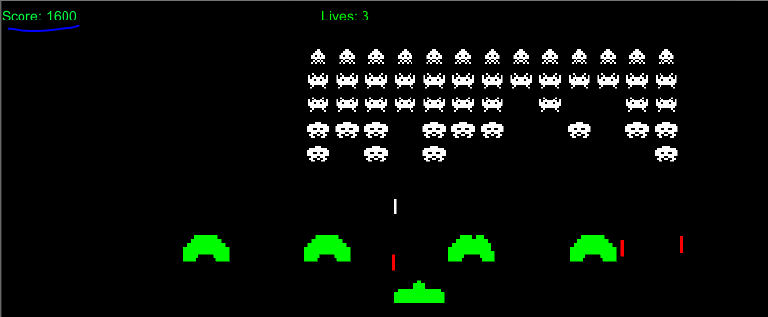

#### Lives

The lives system uses the same system of the score system except the lives are subtracted and when they reach zero the game ends. The feature is nearly the same are the score system except the numbers are going down instead of up and react to the player more.

#### UFO

The random UFO that appears within the game shares many similarity with the aliens but instead only appears once and offers more points if hit. Moving from one position to the end where it will disappear if not hit the saucer will not appear again within the game. This offers the player a bigger challenge since it only appears once and offers more point as incentive.

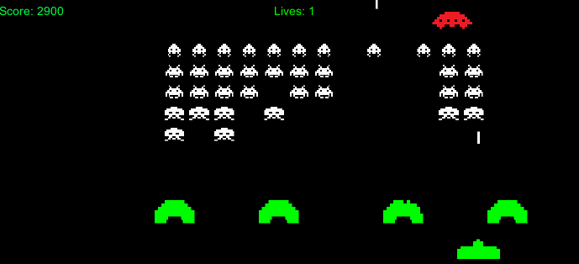

##### **Problem that arose.**

During the creation of this many problems presented themselves and were solved with more effort that deserve note

* Audio issues

During the addition of audio, the aliens offered an issue where they would not play the destruction sound upon when they are hit. This issue was since within the code the game object would be destroyed once hit and since the audio file is attached to these objects that would also be destroyed and therefore would not be played.

To solve this issue I implemented the PlayClipAtPoint() which would play the audio clip at a certain position which I set to the be the last position of the aliens that was destroyed.

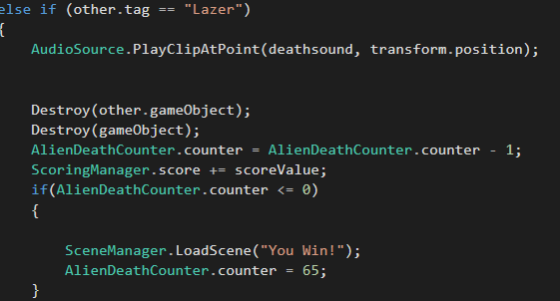

* Shields creation

The shield was a more tedious creation clipping each and every block into the proper formation was difficult but the help alleviates this work load we created a prefab of the firt created shield and issues this prefab for the next three. These prefabs can be modified much easier and reused for future development.

* Winning the game

To finally win the game we needed to destroy all the aliens object and be shown a message that we won. Upon much thought, I decided the easiest way to accomplish this was to issue a count down. This would be the count of each alien, 65 to be precise, that when destroy would subtract 1 from the total count and once they reach zero the player would be issues with a you won screen. One issue here was the issue with the saucer being included since it is a “bonus” alien. Simply solved we created a separate destroy script that would not interact with the total count. Additionally, we made sure to reset the count each time the user either wins or loses the game

## Five Improvement

Here we will be going through the different suggestions to help improve this game in a modern context.

1. **Graphics**

The graphics of this game are during the age of t=when 8 bit was chosen not because of its design but because it was all that was available.

In today’s world, we can implement much better graphics even to 2d games. This could be as simple to used newer more detailed sprite sheet, to using much more advanced 3d sprites in a 2d setting, particle effects, lighting and shadows there is much to implement in the ways of graphics since there is so little within this game.

1. **Audio**

Again, much like the graphics the audio of the games was good for the time it was created but today there is entire libraries online specially made sound effects that can be easily implemented with Unity. Using these sound effects can help the player become more immersed and create a better gaming experience.

1. **New Game Layout**

The gameplay of this game is very simple, which is not to say this is a bad thing such as there have been games with simple mechanics that have been very popular in the last couple years, for example Flappy Bird a mobile game with only one control, but this simple gameplay need only one changes to completely re-invent it. Add the inclusion of shooting up down left and right. Create a box sparsely surrounded by shields and random alien waves spawning on either dies of the player. This simple change would add a new dynamic and help keep the player on their toes, keeping the fire rate low to make it easy at the beginning but increasing this as the levels progress will help increase the challenge for the player.

1. **Power Ups**

Space Invaders seemed to lack this during the time of its creation a shame considering 8 bit titles such as Super Mario Bros. did well to implement it not long after it was made. Using these would also not be hard to implement. Creating a script that would be attached to each space invader that would have a chance of spawning an item that’s could do different effect for example, increasing the rate of fire, stopping enemy movement or adding an extra life. The item could also be coded to only interact with the player tag as it falls so the shield does not block the item. Power ups are enjoyable reward for the player as they play and fun to use in challenging levels.

1. **Mobile Platforms**

Everyone in today’s modern world has likely place a small game on their phone some much more complex than Space Invaders so it makes a lot of sense to include this game as a mobile game. Since it is rather simple and would not require a lot of hardware to play a smart phone could easily run this game and allow people to play 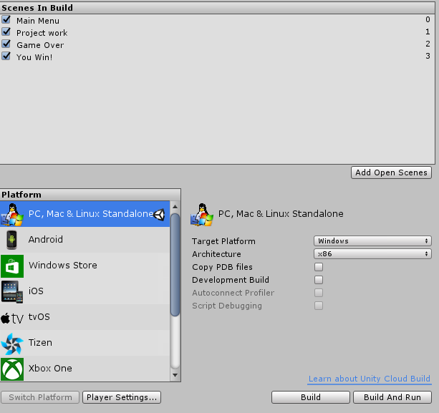it where ever they would like. Unity can also do this by building the game for android devices within its building settings

# References

Online Tutorials:

* **Unity 5 Tutorial Part 3 SpaceInvaders**

Author:

[Lucas Hartman](https://www.youtube.com/channel/UCIXAr0DpqYwKAK6blfX4z9w)

<https://www.youtube.com/watch?v=MGRv00yStDk>

* **The Unity Beginner's Arcade Corner- Invaders #6- Enemy movement**

Author:

[Press Any Button](https://www.youtube.com/channel/UCqKVl5fBlXEzx4U1G0DEfvg)

<https://www.youtube.com/watch?v=oEYsJAIYfFs>

* **Unity Space Shooter Tutorials**

<https://unity3d.com/learn/tutorials/projects/space-shooter-tutorial>

Resources:

* Audio

ClassicGaming

http://www.classicgaming.cc/classics/space-invaders/sounds

* Sprites

Author: [GooperBlooper22](http://gooperblooper22.deviantart.com/)

http://gooperblooper22.deviantart.com/art/Space-Invaders-Sprite-Sheet-135338373